## Problem 2 – Sudoku

### Sudoku is a logic-based, combinatorial number-placement puzzle. The objective is to fill a 9×9 grid with digits so that each column, each row, and each of the nine 3×3 sub-grids that compose the grid contain all of the digits from 1 to 9.

On the pictures bellow you can see a Sudoku puzzle and its solution:

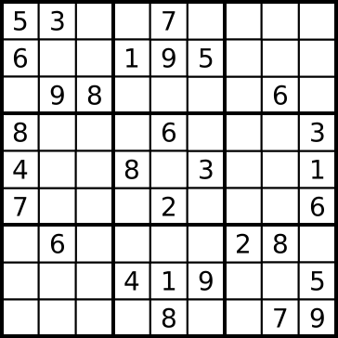 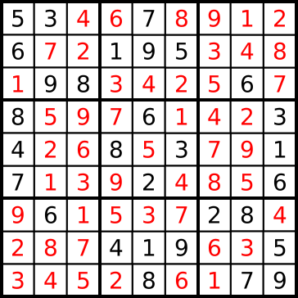

### You are given a partially completed grid, which always has a unique solution. Your task is to solve the given Sudoku puzzle.

### Input

The input data should be read from the console.

You will be given 9 lines with 9 symbols with numbers and dashes. The dashes represent empty cells.

The input data will always be valid and in the format described. There is no need to check it explicitly.

### Output

The output data should be printed on the console.

You should print the solved Sudoku puzzle. See the examples bellow.

### Constraints

* Allowed working time for your program: 0.2 seconds. Allowed memory: 16 MB.

### Examples

|  |  |
| --- | --- |
| Input example | Output example |
| 53--7----  6--195---  -98----6-  8---6---3  4--8-3--1  7---2---6  -6----28-  ---419--5  ----8--79 | 534678912  672195348  198342567  859761423  426853791  713924856  961537284  287419635  345286179 |

|  |  |
| --- | --- |
| Input example | Output example |
| ---2---63  3----54-1  --1--398-  -------9-  ---538---  -3-------  -263--5--  5-37----8  47---1--- | 854219763  397865421  261473985  785126394  649538172  132947856  926384517  513792648  478651239 |